Math 1 Name_______________________________

**3-2 Practice 2** Date________

Learning Goals:

* *I can explain why and identify some systems of equations that have no solutions and some that have infinitely many solutions.*
* *I can solve systems of equations graphically, using elimination and substitution.*
* *I can identify the solution of a system of equations as an intersection point on a graph.*
* *I can write, solve and graph the system of equations and/or inequalities that best models the real-world problem.*
* *I can infer that since $y=f\left(x\right)$ and $y=g\left(x\right), f\left(x\right)=g\left(x\right)$ by the substitution property.*

Solve the following systems using substitution. Show your work and check your answer.

1.   2. 

3.  4. Solve by graphing: 

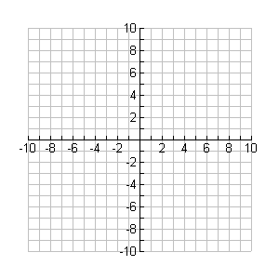

1. 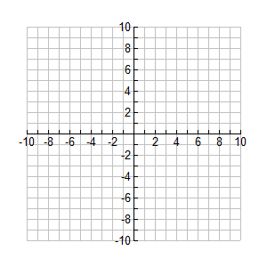Graph the following on the coordinate plane.
2. 
3. What is the solution to the system? _________



1. Graph the following on the coordinate plane.
2. 
3. What is the solution to the system? ____________

Solve the system using substitution.

7. ** 8. **

9. ** 10. 

11.  12. 

13. ** 14. 

15.  16. 

17. 18. 

19.  20. 